News Release
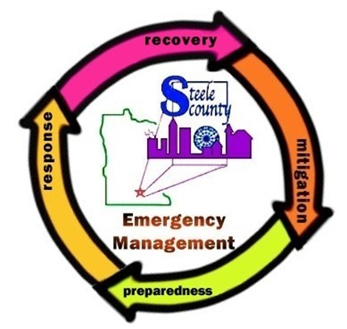
FOR IMMEDIATE RELEASE: 09/15/2023
Contact: Kristen Sailer
Steele County Emergency & Risk Management Director
kristen.sailer@steelecountymn.gov
507-444-7501

Public Feedback and Participation Invited for
Steele County 2023 All-Hazard Mitigation Plan Update
Steele County, Minnesota - The Steele County Emergency & Risk Management Department is currently working on the 2023 Steele County All-Hazard Mitigation Plan and invites the residents of Steele County to provide input and feedback. The plan is a requirement of the Federal Disaster Mitigation Act of 2000 (DMA 2K) and must be update every 5 years (an additional year has been added due to the COVID-19 pandemic) to maintain eligibility for certain hazard mitigation funding programs.

Development of the plan is under the direction of Steele County’s Emergency & Risk Management Director in cooperation with a planning team that includes stakeholders from the County departments, local municipalities, townships, utitilies and other key stakeholders. The planning team is responsible for providing feedback on the planning updates including the ranking and identification of strategic, cost effective mitigation activities to reduce future losses for county and local jurisdictions. Some mitigation activities may be eligible for future Federal Emergency Management Agency (FEMA) Hazard Mitigation Assistance (HMA) programs grant funding for projects. Projects can include: localized flooding reduction measures, property aquistion and relocation/conversion to open space, infrastructure retrofits, wildfire mitigation, safe room construction for life-safety protection in weather related events.

About The Plan
The Steele County All-Hazard Mitigation Plan 2023 covers all of Steele County, includuing Blooming Prairie, Ellendale, Medford, Owatonna, townships, and other stake holders. Steele County is vulnerable to a variety of potential life-threatening events that include, but not limited to: tornadoes, wildfires, flooding, blizzards, ice storms, droughts, and straight-line winds. Natural disasters have a potential for causing major economic losses and personal hardships. The plan will address hazard mitigation strategies, actions, and improvements that will help to limit loss from emergency disasters.
“It is not “if” a disaster will happen; it is “when” will a disaster happen. Hazard mitigation is one the best things we can do to minimize damage and costs to the people and property in our County.” Megan Norbeck, Steele County Emergency Management Deputy Director

Examples of hazard mitigation actions include adding more sirens, automatic flood guages, and community safe rooms for tornadoes to vulnerable areas. Other examples include updating and improving culverts and roads, burying powerlines, conducting public awareness and education campaigns, and providing timely emergency communication alerts.

Public Feedback and Participation is Encouraged
The planning process includes gathering and processing input from the community. This step is required as part of the mitigation planning and provides Steele County residents and businesses with the opportunity to provide feedback about how best to prepare Steele County.
- What natural hazards do you feel pose the most risk to your community?
- Have you experienced a previous disaster event?
- Do you have any concerns and ideas do you have about mitigation actions or projects that you feel could reduce the damage of future events that could affect your personal, business, or community as a whole?
The public is strongly encouraged to submit any comments, concerns, or questions about natural disasters and potential hazard mitigation actions to be included in the plan updating process.

Please submit feedback by October 10, 2023 to the Steele County Emergency & Risk Management Director, Kristen Sailer: 507-444-7501 or Kristen.Sailer@SteeleCountyMN.gov. Comments can also be submitted through the Steele County Emergency Management website at https://www.steelecountyemergency.com/mitigation/ and Facebook page: www.facebook.com/SCEmergencyManagement

The public will have a continued opportunity to participate in the Steele County All-Hazard Mitigation Plan 2023 update in the upcoming months. A draft of the plan will be posted to the County website for public review, public meetings will be held throughout the county, and future news releases will be shared with the media to notify the public of these opportunities of involvement.
********

